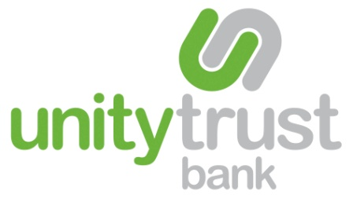
Unity e-Payment
Service Information Form

Introduction
To begin the migration, you are required to complete this form so that your existing configuration is migrated to the new Unity e-Payment platform. Our partners Bottomline Technologies will contact you to support you through the migration process and will provide training on using the new platform.

User Information
Please detail two primary users that will need access to the service. Further users can be added once migration is complete.

Full Name | Email Address* | Job Title
* Each user will need an individual email address so that they can log in to Unity e-Payment, this must be unique to the user and not a shared access email address.
To ensure the new platform can read your data correctly Bottomline Technologies require a sample file for each of the current templates. This is to ensure that the Unity e-Payment platform can submit your transactions to Bacs successfully. Please supply a sample file(s) for each template when you return this form.

Next steps
Once you are happy with the information detailed in this document, please sign and return it by email to Bottomline Technologies (unity@bottomline.com) along with your sample data.

Bottomline will call you once they have transferred your information to the new platform to confirm everything is in order and to book your system testing and training date.

If you have any queries regarding your migration please contact our partner Bottomline Technologies on 0118 953 6930 or email unity@bottomline.com.

Signed …………………………………………………………………

Name …………………………………………………………………

Date …………………………………………………………………

This must be signed by a Unity Trust Bank account signatory.

